Pokhara University

Level: Bachelor | Semester – Fall | Year : 2009
Programme: BE |  | Full Marks : 100
Course: Strength of Materials |  | Time : 3hrs.

Candidates are required to give their answers in their own words as far as practicable.
The figures in the margin indicate full marks.

Attempt all the questions.

1. | - Explain determinate and indeterminate structures with examples and suitable sketches.  - Derive Euler’s formula for critical load for a column with one both the ends hinged. | 5  10
2. | Calculate principal moment of inertia product of inertia and radii of gyration of the given composite section about given x and y axes. Show the principal axes in the figure. Also calculate polar moment of inertia of the section.  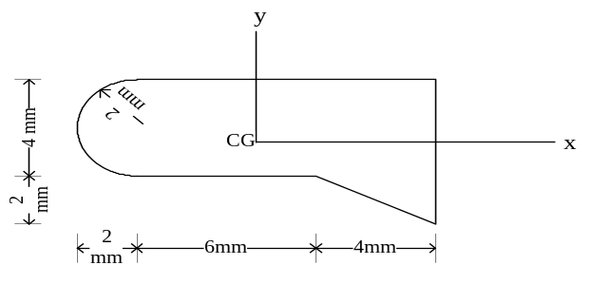 | 15
3. | - Find the elongation of bars showing in figure under tensile load of 40kN. Take E = 2×10⁵ N/mm².  - Draw the bending moment and shear force diagram of the beam loaded as shown in the figure. | 10  5
4. | - Draw the shear force, axial force and bending moment diagram for the rigid frame given in figure below.  - A cylindrical vessel 2m long and 500mm in diameter with metal thickness 10mm is subjected to an internal pressure of 3.5MPa. Calculate the change in length, diameter and volume of the vessel. Take E = 2.1×10⁵ N*mm², m = 1/0.3. | 10  5
5. | Magnitude and directions of normal and shear stresses acting on the two planes intersected at a point of an element are as shown in the figure below. Calculate:  - principal stresses  - orientation of principal stresses and show on the figure  - maximum stress and show its orientation on the figure  - Verify the result by Mohr’s circle  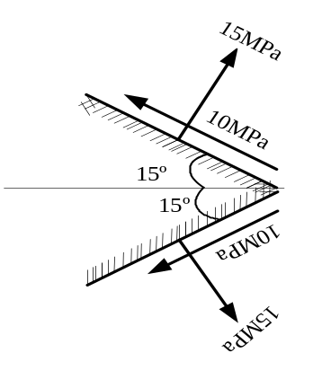 | 15
6. | - Two beams have the same length, same allowable stress and the same bending moment. The cross-section of the beams are a square and a circle. Find the ratios of weights of the circular beam with respect to the square beam.  - A solid steel of 60mm diameter is to be replaced by a hollow shaft of same material with internal diameter equal to half of the external diameter. Find the diameters of the hollow shaft an saving in material, if the maximum allowable shear stress is same for both shafts. | 7  8
7. | Write short note on (Any Two)  - Slenderness ratio  - Shearing stress in beams  - Relation between elastic constants | 5×2

